Join Uber Conference Instruction
週六內在生活分享禱告會 Uber Conference information:
- Link : https://www.uberconference.com/emmainplano
- Call in USA: 716-293-7513, see 3.2 for other country number detail.
Please follow the instruction below for PC or Mac computer. UberConference works with Chrome browser ONLY.
- PC (Windows operation system) Computer 微软电脑
  - Install the Chrome browser if your computer did not have it yet 安装Chrome

Go the link https://www.google.com/chrome/ or https://www.google.com/chrome/browser/desktop/index.html (For Windows 8.1/8/7/Vista/XP 32-bit) to download Chrome and install on your computer
  - Open Chrome browser, type in the link: 打开Chrome
https://www.uberconference.com/emmainplano
  - You will see following screen: 你可以看到下面的屏幕

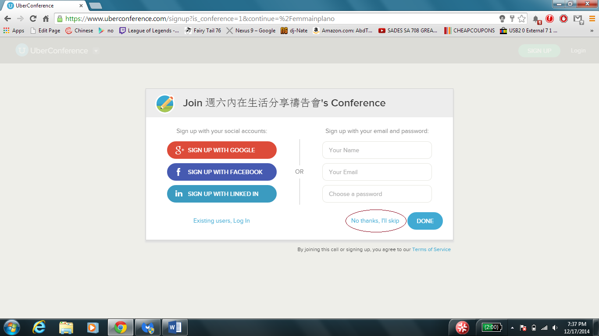

Select “No thanks, I’ll skip” 选择“No thanks, I’ll skip”

  - You will see following screen: 你可以看到下面的屏幕

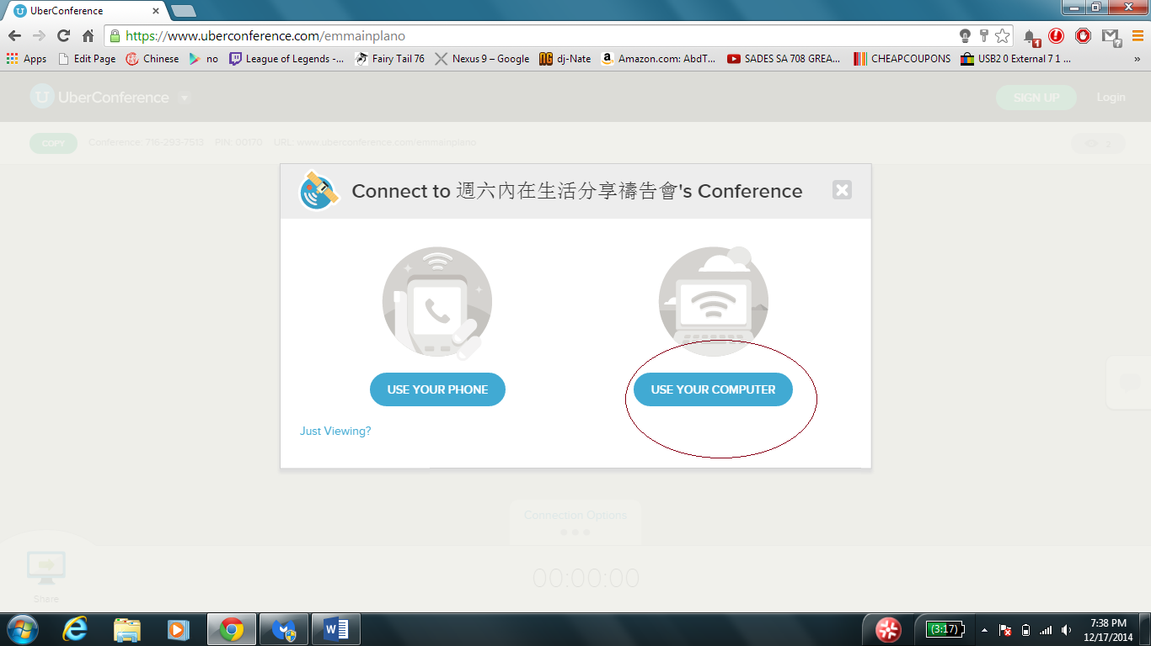

Select “USE YOUR COMPUTER” 选择“USE YOUR COMPUTER”

  - You will see the following screen, type your name, and click “CONNECT” 你可以看到下面的屏幕，请输入你的名字
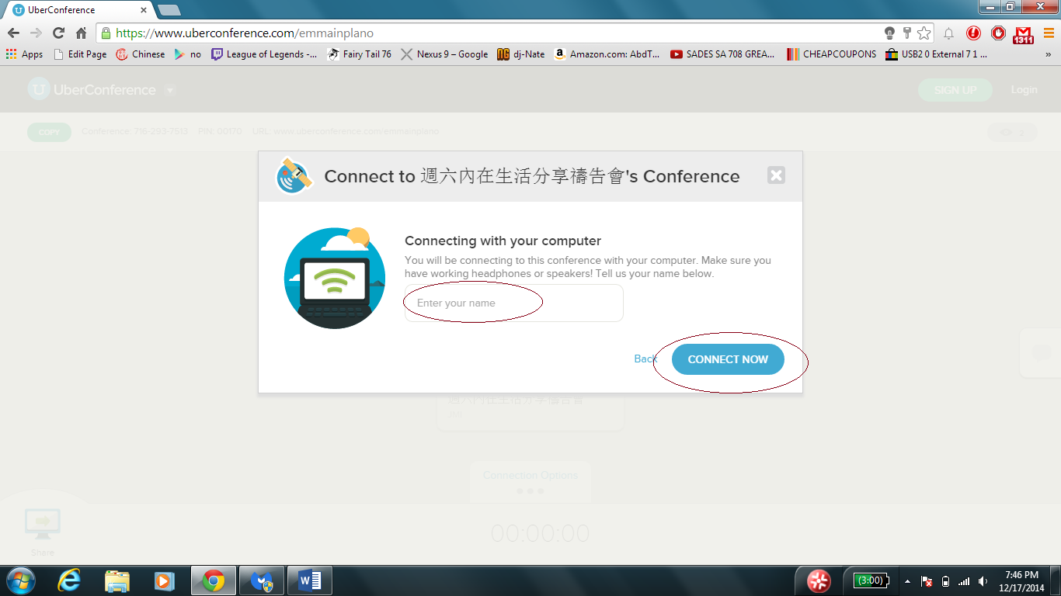

  - You will see following screen, and you are in the meeting! 你可以看到下面的屏幕，你已经加入会议了。
Please click the Mute button if you are not talking.
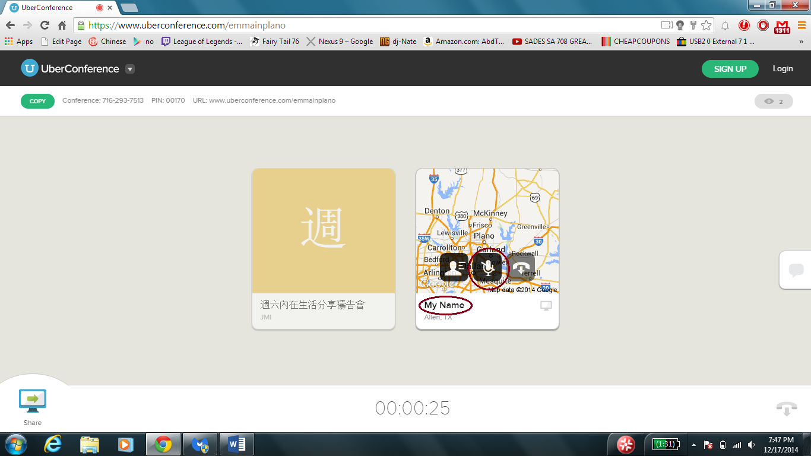

- Apple MacBook (OS X operating system) 苹果电脑
  - Install the Chrome browser if your computer did not have it yet 安装Chrome
Go the link https://www.google.com/chrome/ to download Chrome and install on your computer
  - Open Chrome browser, type in the link: 打开Chrome
https://www.uberconference.com/emmainplano
  - You will see following screen: 你可以看到下面的屏幕
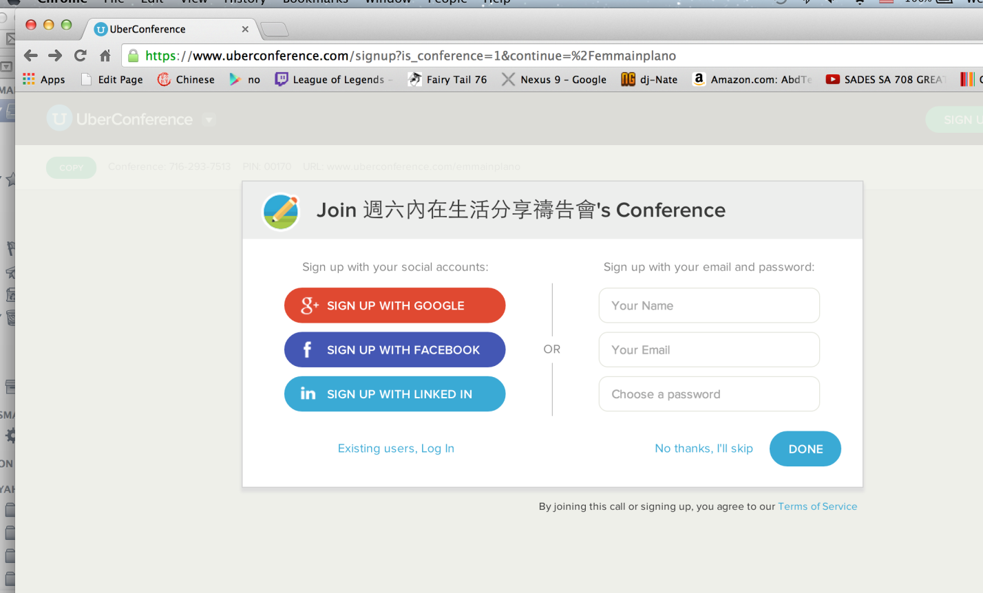

  - Type “No thanks, I’ll skip”

  - Type your name, and click “CONNECT”

  - You will see following screen, and you are in the meeting!
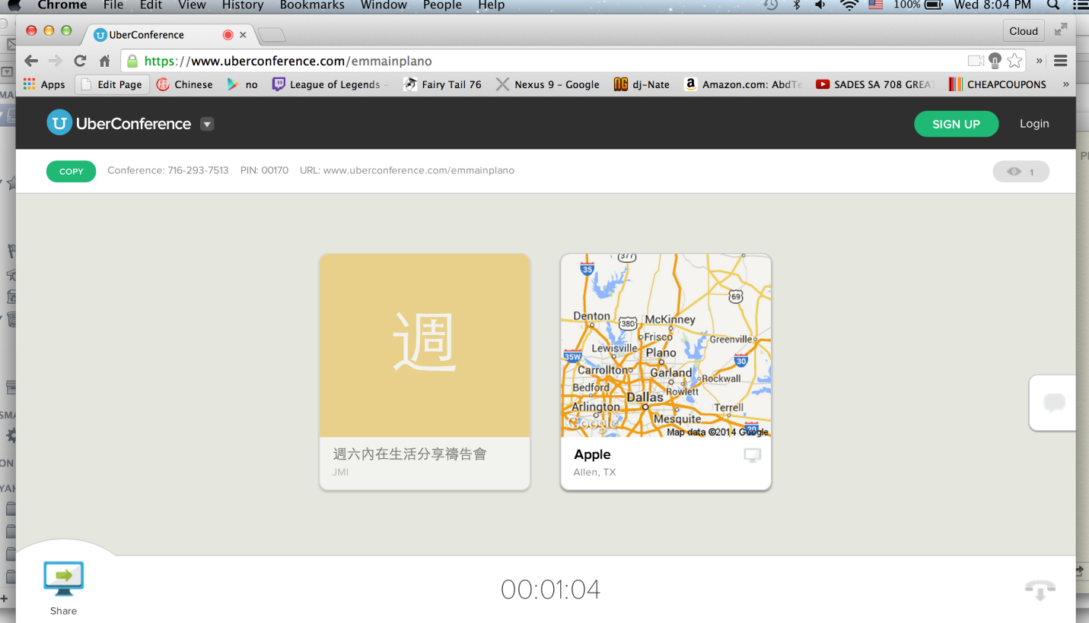

- Mobile device (iPhone, other smart phone) or landline phone 由电话参加会议
  - US or Canada callers 美国，加拿大
Please dial 716-293-7513
You are in the meeting !

  - International callers. 国际
Unfortunately, there is local number in China or Taiwan. 没有中国或台湾。
- Dial the local number below based on your location.
Hong Kong香港 : 5808 3219
Malaysia 马来西亚 : 03-8988 5116
Singapore 新加坡 : 3158 0641
Japan 日本 : 03-4578-0172

http://www.jmiinnerlife.org/wp-content/uploads/2015/01/Join-Uber-Conference-Instruction.docx

